## WWII POW Survives Bataan Death March, Witnesses Atomic Bombing of Nagasaki

By Peter H. Michael

This article appeared in the Utica, New York, *Observer-Dispatch* and the Frederick, Maryland, *Frederick News-Post* in August, 2005. The author is a cousin of Harvey Michael III, the subject of the article.

❦

Harvey Michael III, Frederick County native and World War II veteran, witnessed the atomic bombing of Nagasaki on August 9, 1945 as a prisoner of war. Harvey Michael was my cousin, and related his astounding World War II experiences to me in late 2002 shortly before he died. He was the great-grandson of Margaret and Ezra Michael who had used the Michael family's ancestral farm near Adamstown, Maryland, as a safe-house on the Underground Railroad. The beginning of Harvey’s unique World War II story finds him following in his family’s footsteps.

In August, 1941, on the eve of World War II, Harvey Michael III, United States Army enlisted man barely out of his teens, arrived in The Philippines. There at a favorite restaurant, he met Cha Lee, a young Chinese waitress, and took a fancy to her. When Cha Lee stopped working at the restaurant, Harvey inquired with her work mates as to her whereabouts and was directed to the home of a wealthy Spanish Filipino where he found Cha Lee and learned from the Spaniard that he had purchased Cha Lee as his slave in Hong Kong when she was six, and that the enslaver had used the child for labor and sex ever since. Harvey immediately attempted to escort the young woman off the property but was prevented at gun point from doing so. On the spot, Harvey negotiated the purchase of her freedom, went to his barracks where he had to borrow from his friends to make the price, went back to the home of the Spaniard, and bought Cha Lee’s freedom the same day.

Until Harvey explained after leaving the Spaniard’s house, Cha Lee thought that she had been sold from one enslaver to another. Since she had no money, Harvey found her a room, paid several months’ rent in advance for her (at five dollars per month), and gave her enough pocket money to support herself until she could find a job, taking nothing in return for his kindnesses. The young couple began dating, and became fond of one another. As Harvey explained, he “treated her like a lady” with only the most innocent of affections passing between them, and then only on her front door step. Harvey’s Army buddies gave Cha Lee the nickname Charlie, and she became a kind of adopted kid sister to all of them. She was sixteen.

In December, 1941, Japan invaded The Philippines and in April 1942 Harvey was captured. He survived the Bataan Death March, and later in 1942 was shipped to Japan where he was forced into slave labor in a coal mine near Nagasaki. In an astonishing twist of fate, the freer of a slave had become a slave.Three years later on August 9, 1945, Harvey happened to be above ground one day for a rare treat of fresh air and sun when he became an eye witness to the atomic bombing of Nagasaki. Within weeks, he was freed by American forces and rather than going home requested to be sent back to The Philippines so that he could find Cha Lee and ask her to marry him. Upon his arrival there, he learned that the Japanese had re-enslaved Cha Lee as a “comfort woman,” a slave-prostitute used by Japanese soldiers, which is how she died while still in her teens. Harvey then returned home broken-hearted.

The young woman knew only a few months of freedom and happiness in her brief life and then only because of the good instincts of the young American Army soldier, Harvey Neuman Michael III. And so, Ezra and Margaret Michael and their children turned out not to be the last of Harvey’s family to usher an enslaved person to freedom when operating their Frederick County farm as an Underground Railroad safe-house; in an astonishing turn of events seventy-six years after the Civil War ended, Ezra and Margaret’s great-grandson Harvey III, squarely in his family tradition, gained this distinction.

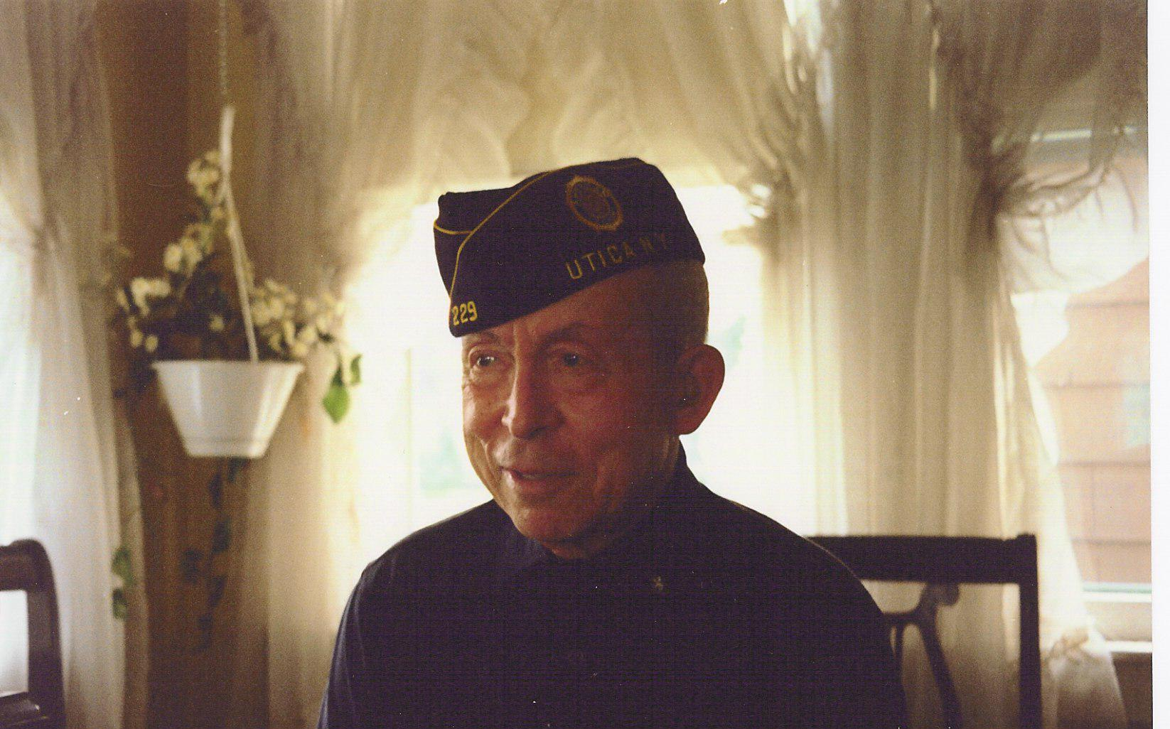A few years after returning from The Philippines, Harvey married, but the couple never had children. As he explained it, while waiting for his ship to take him from Nagasaki to Manila, he spent the day sitting on a curb covered with the litter of atomic fallout and having no idea of radioactivity or its danger. Harvey and his wife adopted two daughters, one of them Chinese. Harvey worked as a pressman for a printing company in Utica, New York, retiring in the 1980s. He is shown here near the end of his days in his Veterans of Foreign Wars cap.

On the morning of Thursday, December 19, 2002 at the age of eighty-two and now a widower, Harvey Neuman Michael III was run down by a car while walking home from his church where he volunteered. He used a walker. I had met Harvey only by telephone and not until that year. We had planned to meet in person in January 2003. How I would have enjoyed meeting this good old soldier with the kind heart who had followed his family tradition more than sixty years before in freeing the young Cha Lee. Perhaps they cross paths now.